Dear students,

Some of the students are facing issue of port conflict as some other application they have installed is already running on 8080.

In such case you can change your tomcat port. To do that go to Your tomcat installation folder and then  **conf**  folder, there you will see an xml file named “server”

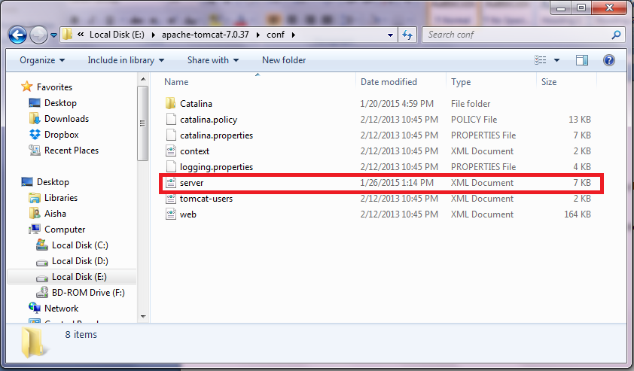

Open this file. Locate following line

<Connector executor="tomcatThreadPool"

port="8080" protocol="HTTP/1.1"

connectionTimeout="20000"

redirectPort="8443" />

And replace 8080 to new port no. you want to assign e.g. 8001, so above will change to:

<Connector executor="tomcatThreadPool"

port="**8001**" protocol="HTTP/1.1"

connectionTimeout="20000"

redirectPort="8443" />

Restart tomcat and open **localhost:8001** in your browser, you’ll see tomcat index page.